**Section Two: Problem-solving 50% (78 Marks)**

This section has **six (6)** questions. Answer **all** questions. Write your answers in the spaces provided.

Suggested working time: 90 minutes.

**Question 15 (13 marks)**

An eagle has captured a fish and is 14.7 m directly above the water when it releases the fish. The eagle is moving with a velocity of 5.20 m s-1 at an angle of 36.6o above the horizontal when the fish is released. Ignore air resistance for calculations.

36.6°

5.20 m s-1

14.7 m

This diagram is NOT to scale

(a) Calculate the time taken for the fish to reach the water. (4 marks)

(b) Calculate the horizontal distance that the fish travels during its flight back to the water.

(3 marks)

(c) Calculate the velocity of the fish when it hits the water. (3 marks)

If air resistance is taken into account then the flight path is altered.

(d) Sketch the altered flight path onto the diagram. (1 mark)

(e) Will the time of flight be longer or shorter when air resistance is taken into account? Discuss the factors that affect this. (2 marks)

**Question 16 (16 marks)**

The moons of Saturn are numerous and diverse – ranging from tiny ‘moonlets’ one kilometre across to the enormous Titan, which is larger than the planet Mercury. Saturn has 62 moons with confirmed orbits – 53 of which are named and only 13 have diameters larger than 50 kilometres. Data for two of the moons are provided below:

|  |  |  |  |  |
| --- | --- | --- | --- | --- |
| **NAME** | **DIAMETER**  **(km)** | **MASS (kg)** | **ORBITAL RADIUS (km)** | **ORBITAL PERIOD (Earth days)** |
| **Mimas** | **396** | **4.00 x 1019** | **1.86 x 105** | **0.90** |
| **Dione** | **1123** | **1.10 x 1021** | * 1. **105** |  |

(a) The diagram below shows Saturn; approximate representations of the orbits of its two moons, Mimas and Dione; and the moons’ positions at a particular point in time. On the diagram below, draw two vectors (arrows) that indicate (i) the direction and (ii) strength of the gravitational field due to Saturn’s mass at the points indicated. Ignore any gravitational effects the moons’ masses may have on the other.

(2 marks)

**DIONE**

**MIMAS**

**SATURN**

(b) Using the data provided for Mimas and Dione in the table above – as well as Kepler’s Third Law - calculate the orbital period for Dione in Earth days. (4 marks)

(c) Use the data provided for Mimas to calculate the mass of Saturn. (4 marks)

(d) Which moon has the higher orbital speed - Mimas or Dione? Explain without calculating any values. (3 marks)

(e) NASA intends to insert a probe into an orbit around Saturn for scientific observations of its weather. Two students are discussing this probe; one student states: “All of the objects in this probe will be weightless because there are no forces acting on an object when it is in orbit.” Is this student correct? Explain your answer. (3 marks)

**Question 17 (10 marks)**

A small object of mass 50.0 g is being rotated freely in a vertical circle of radius 1.50 m. It is attached to a string of the same length. At the position shown (i.e. the top of the vertical circle), the ***tension in the string is momentarily equal to zero***. The string is able to withstand a maximum tension of 2.50 N before it snaps.

object

Direction of motion

v = 1.00 ms-1

r = 1.50 m

X

Y

(a)Which of the arrows below best describes the direction of the object’s motion at point ‘X’?

(1 mark)

|  |  |
| --- | --- |
| A |  |
| B |  |
| C |  |
| D |  |

**ANSWER: _______________**

(b) Show via calculation that the object is travelling with a speed 3.83 ms-1 when it is at the top of the vertical circle. (3 marks)

(c) Given that the object is rotating freely under the influence of gravity, calculate what its speed would be if it reached the bottom of the circle at point ‘Y’. (3 marks)

(d) Hence determine whether the string would snap before the object reaches Y’. Support your answer with a calculation.

[If you were unable to calculate an answer for part (c), use a value of 8.60 ms-1]

(3 marks)

**QUESTION 18 (14 marks)**

A crane lifts 7.00 x 102 kg load of concrete on a building site. The 8.00 m crane arm is uniform and has a mass of 3.00 x 102 kg. The cable used to raise and lower the load is attached to the crane arm 6.00 m along the arm.

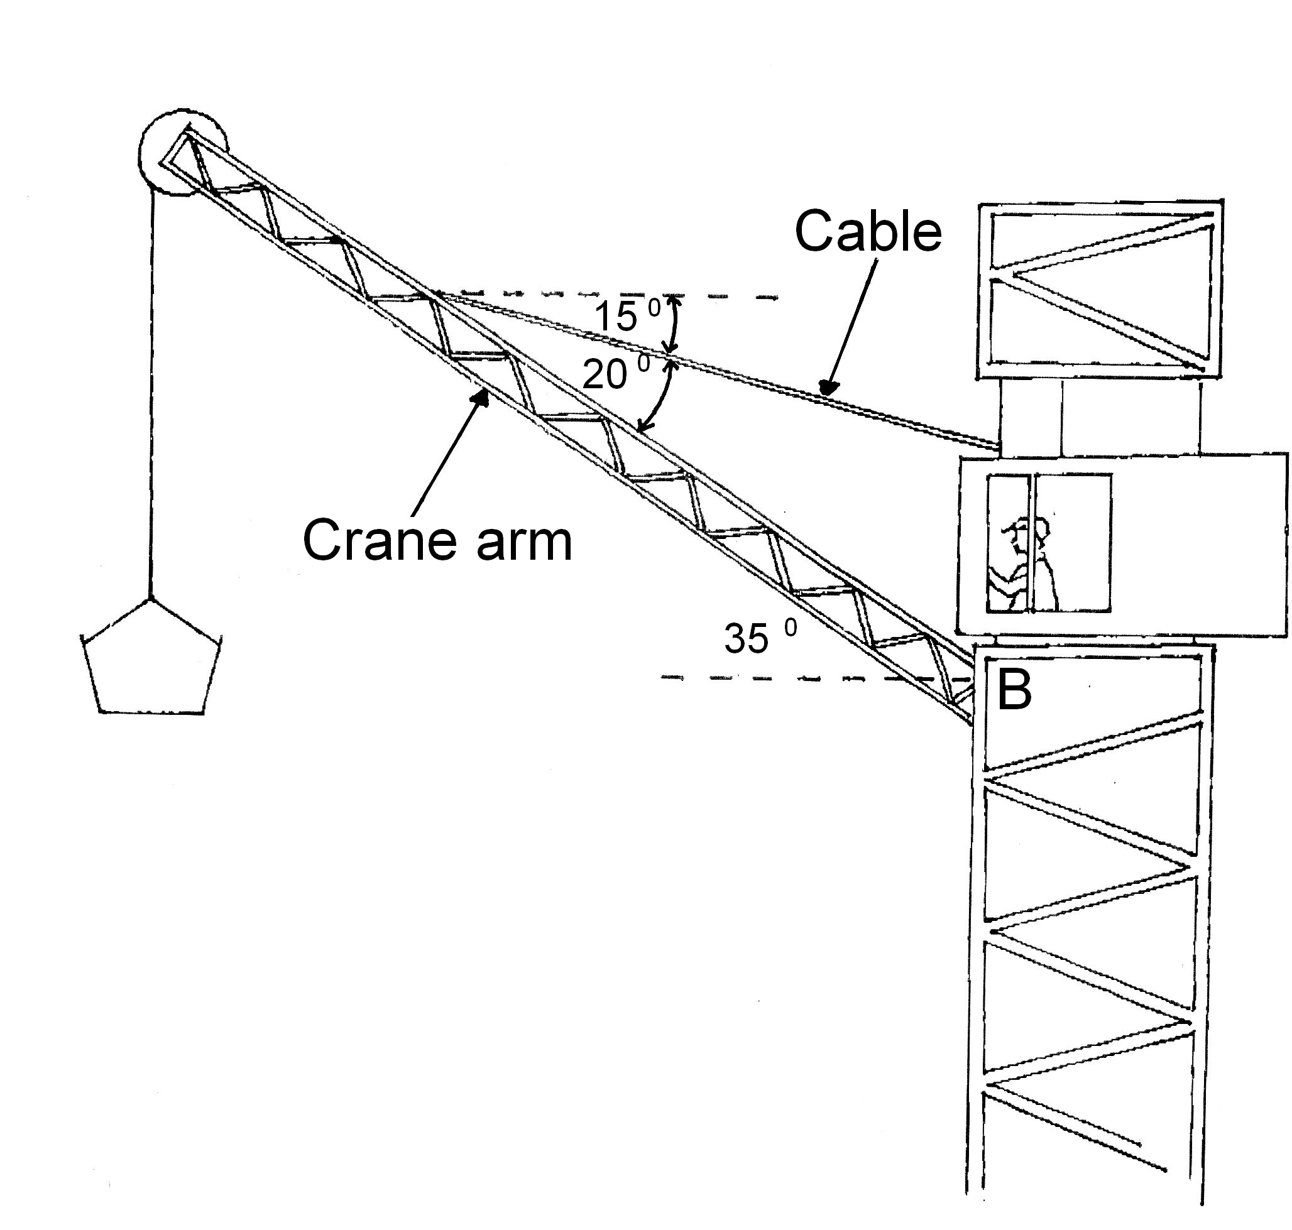

(a) On the diagram, draw the forces acting on the crane arm. (3 marks)

(b) Calculate the tension in the cable. (4 marks)

(c) Calculate the reaction force at the base of the crane arm (B). (4 marks)

(d) Describe what would happen to the magnitude and direction of the reaction force as the crane is lowered to a 30.0° angle to the horizontal. Justify your answer - no calculation is required. (3 marks)

**Question 19 (15 marks)**

The graph below shows how the torque on one (1) coil in an experimental DC motor varies over time.

**Torque (Nm)**

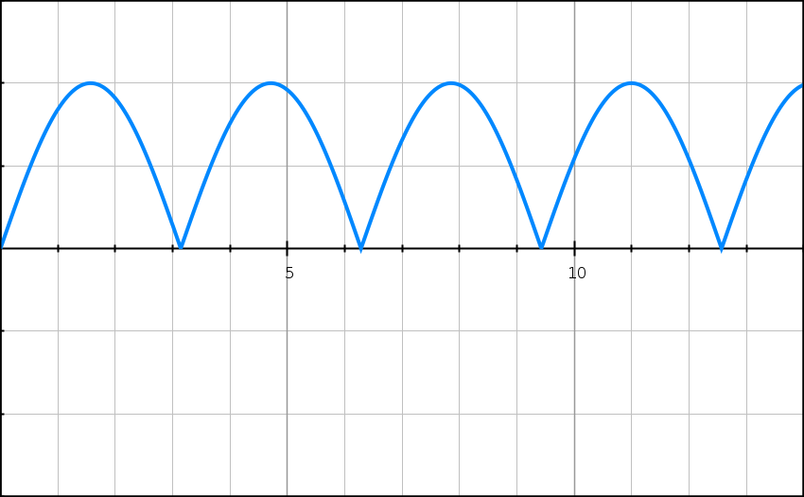

**0.00**

**Time (ms)**

**0.10**

**0.05**

**-0.05**

**-0.10**

(a) On the graph, mark one (1) point where:

(i) the coil would be parallel to the magnetic field. Label this point ‘X’. (1 mark)

(ii) the coil would be perpendicular to the magnetic field. Label this point ‘Y’. (1 mark)

(iii) Briefly explain your answer to part (i). A simple diagram should be included in your explanation. (2 marks)

(b) The shape of this graph suggests the presence of a commutator. Explain why the graph takes this shape, including a description of the commutator. (2 marks)

Some specifications for the coil and the DC motor are shown below:

• Current in coil (I) = 0.500 A

• Dimensions of coil (square shape): 20.0 cm x 20.0 cm

• Number of turns (n) = 20

(c) Using appropriate formulae from your Formulae and Constants Sheet, show that the maximum torque (MAX) generated by the coil can be derived by the following expression:

$$τ_{max}=IBAn$$

where ***B*** is equal to the magnetic field strength in the DC motor. (3 marks)

(d) Using the expression in part (c), the graph at the beginning of this question and the specifications of the DC motor, calculate the magnetic field strength B in the motor.

(3 marks)

(e) If the DC motor ‘jams’ and stops rotating, it has designed safeguards to prevent it from overheating and ‘burning out’. Without describing these safeguards, explain why they are necessary in this particular situation. (3 marks)

**Question 20 (11 marks)**

Alpha particles (He2+) are doubly-charged positive ions and have a mass of 6.64 x 10-27 kg. They are accelerated through an electric field between charged parallel plates before entering a vacuum chamber where they are deflected by a magnetic field.

14.7 m

5.20 m s-1

36.6°

(a) Calculate the potential difference between the charged plates in the ion accelerator that will give the alpha particles a maximum velocity of 3.40 × 105 ms-1. (3 marks)

(b) Between the ion accelerator and the vacuum chamber is a ***velocity selector***, which has an electric field and magnetic field at right angles to each other.

(i) On the diagram below, indicate the direction that the magnetic field must be to ensure the alpha particles maintain a horizontal path. (1 mark)

+ + + + + + + +

- - - - - - - - -

++

(ii) Use the formulas for the force on a charge in an electric and magnetic field to derive the relationship between E and B that gives the velocity of the particles. (2 marks)

(c) Indicate on the diagram, the direction of the magnetic field within the vacuum chamber that will cause the deflection shown. (1 mark)

(d) The magnetic flux density within the chamber is set to 72.5 mT and causes the alpha particles to go into a uniform circular path. Calculate the period of revolution for the alpha particles. (4 marks)